Prior Knowledge Review
- Add the following labels to the light microscope:
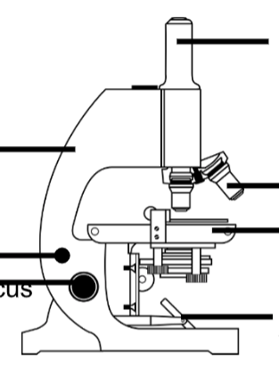
- Eyepiece lens
- Objective lens
- Arm
- Fine focus wheel
- Coarse focus wheel
- Stage
- Light source

- Describe the steps you would follow to view a cell sample under this microscope.
_____________________________________________________________________________
_____________________________________________________________________________
_____________________________________________________________________________
_____________________________________________________________________________
_____________________________________________________________________________
_____________________________________________________________________________
_____________________________________________________________________________
_____________________________________________________________________________
_____________________________________________________________________________
_____________________________________________________________________________

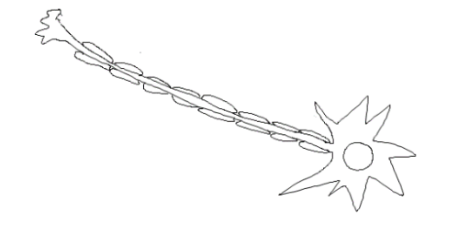
- State the function of each of the specialised cells below and how its structure is adapted for its function:

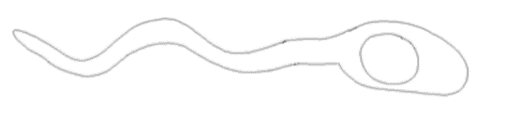

Neuron (Nerve cell)
Function:

Structure:
Sperm cell
Function:

Structure:

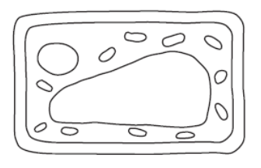
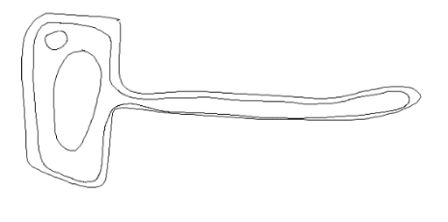

Leaf cell
Function:

Structure:
Root hair cell
Function:

Structure:

- Write the correct keyword for each definition:

- A group of the same cells working together __________________

- A group of tissues working together for the same function __________________

- A group of organs working together for the same function ________________

Stretch Activity
List the organ systems that make up the human body with the function and organs involved in each one.

_____________________________________________________________________________
_____________________________________________________________________________
_____________________________________________________________________________
_____________________________________________________________________________
_____________________________________________________________________________
_____________________________________________________________________________
_____________________________________________________________________________
_____________________________________________________________________________
_____________________________________________________________________________
_____________________________________________________________________________

